**Comprehensive Report on NSS Camp Activities - December 2024**

The NSS camp, held from December 4 to 9, 2024, successfully combined community service, cultural engagement, skill development, and personal growth. Spanning six days, the camp provided 37 participants with meaningful experiences through educational tours, environmental drives, leadership lectures, and creative activities.

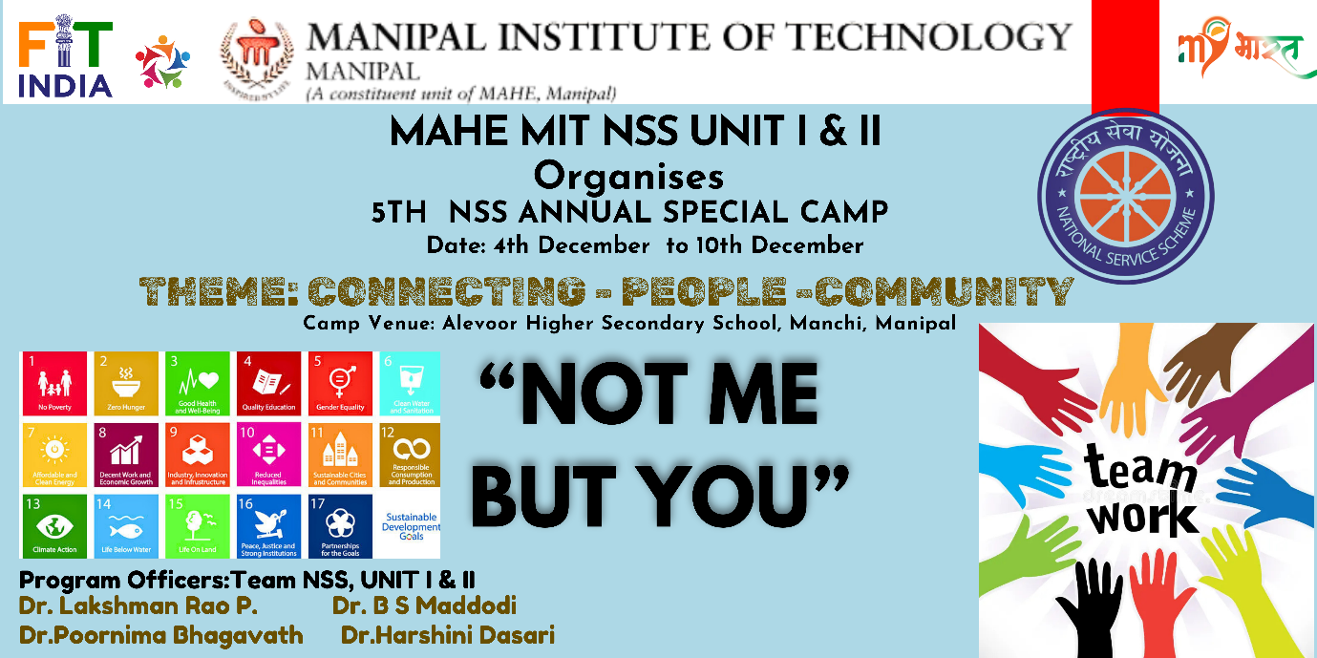

***Day 1: December 4, 2024 - Inauguration and Team Formation***

The camp officially commenced with an introductory briefing where the detailed itinerary for the upcoming seven days was discussed. Participants were briefed on the planned activities, objectives, and expectations. After a short break, attendees were divided into three groups to discuss roles and responsibilities, ensuring effective task allocation and collaboration. The day concluded with a small cultural event that served as an icebreaker, fostering a warm and welcoming environment. A shared dinner at 8:30 PM wrapped up the day on a positive note.

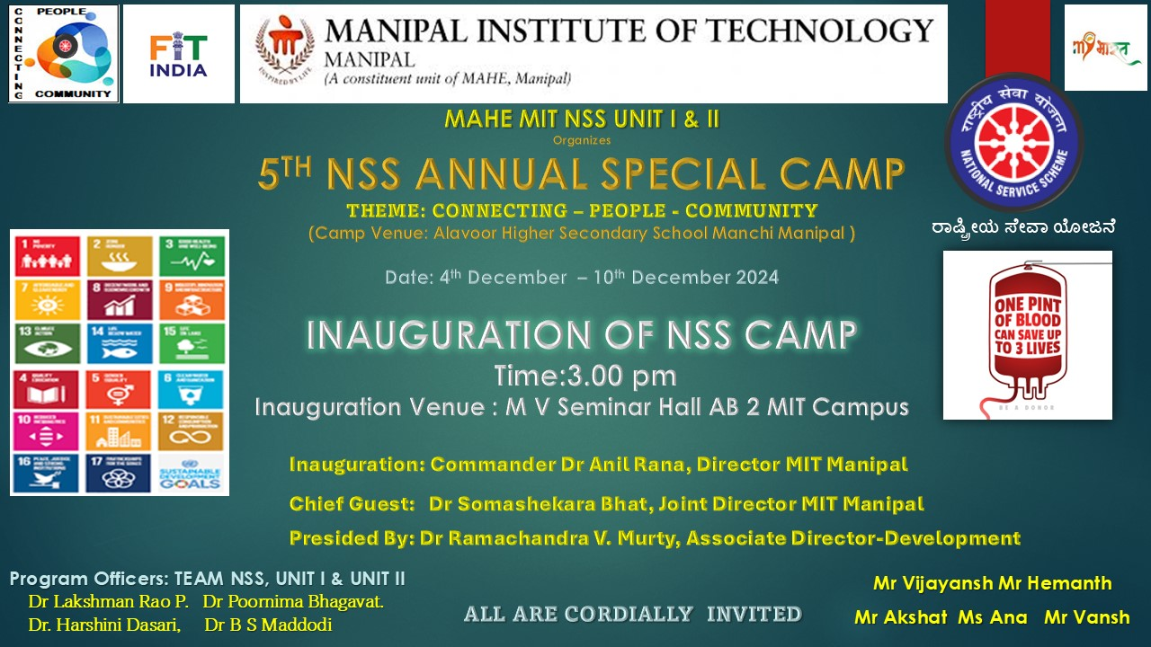

***Day 2: December 5, 2024 - Wellness, Service, and Leadership***

The day began with a refreshing yoga session at AB5, led by a senior student. After breakfast at the college cafeteria, the team proceeded to Allevoor Higher Secondary School for a day of community service. Activities included a school clean-up drive, interactive sessions with students from grades 8 to 10, and a quiz covering general knowledge, science, and math. Younger students enjoyed outdoor games promoting teamwork and cooperation.

In the afternoon, a fun Pictionary game based on movies energized participants, followed by an insightful guest lecture by Lt. Dundesh Chiniwar, Head of NCC. His talk covered skill development, disaster preparedness, sustainable development goals (SDGs), leadership, and digital literacy. The day ended with a delicious dinner and a debrief session to plan the next day’s activities.

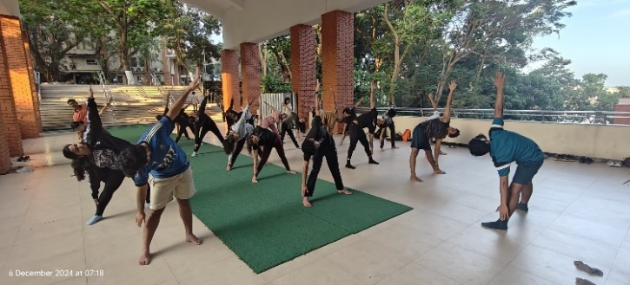 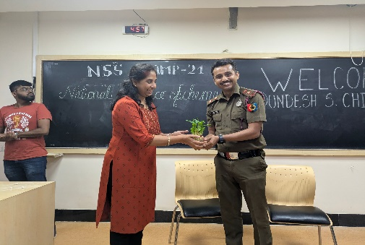

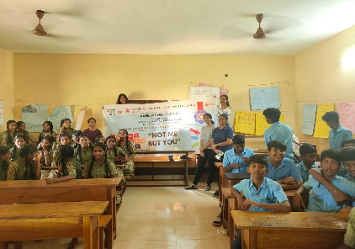 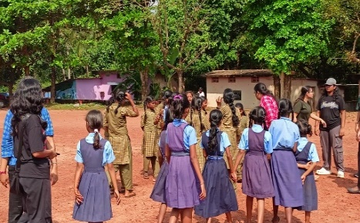 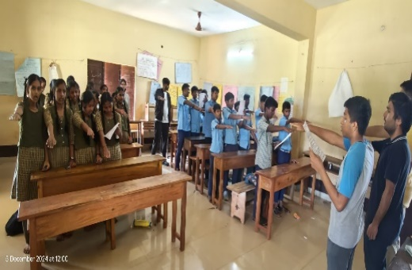

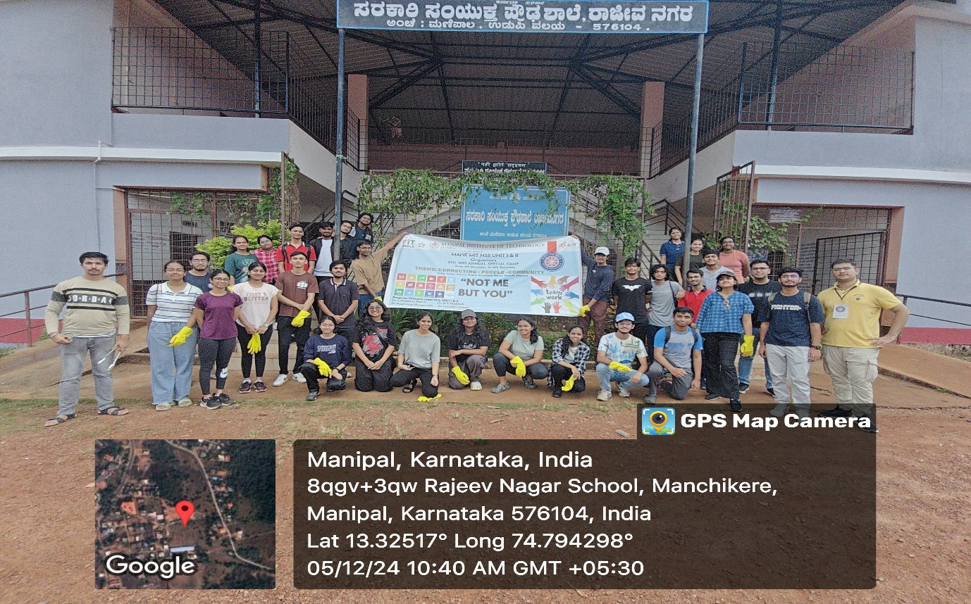

***Day 3: December 6, 2024 - Community Service and Leadership Development***

An early morning jog and yoga session set an energetic tone. After breakfast, the team resumed their volunteer work at Allevoor School, engaging in gardening and planting saplings. This was followed by a campus cleaning drive at ITI College, where students also explored the Electrical and Refrigeration Labs, learning about electrical connections and cooling systems.

After lunch, Dr. Gurumurthy S. C. delivered a powerful leadership lecture, sharing real-life stories, interactive games, and valuable lessons on achieving success. The evening was spent playing games and participating in a sports session at MIT Ground. Dinner at 8:30 PM concluded another productive day.

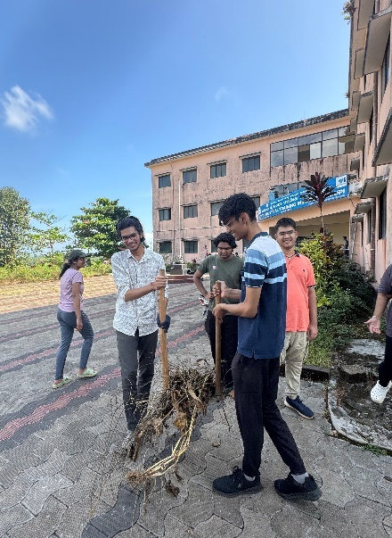 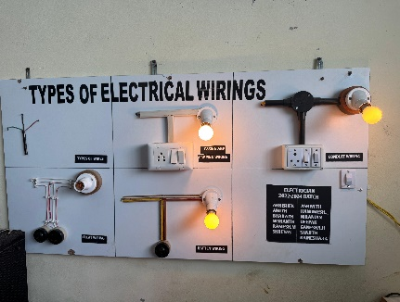 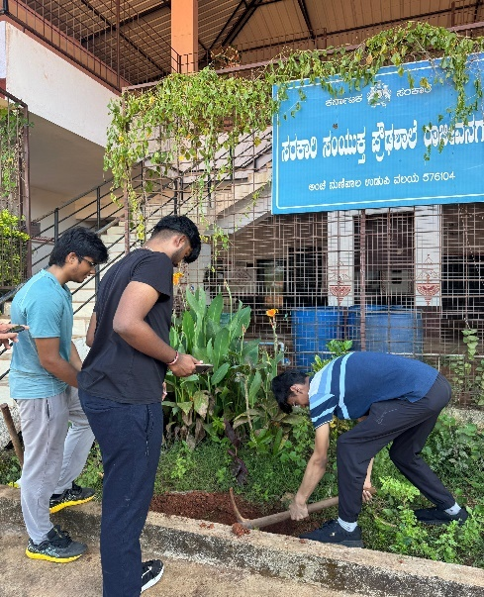

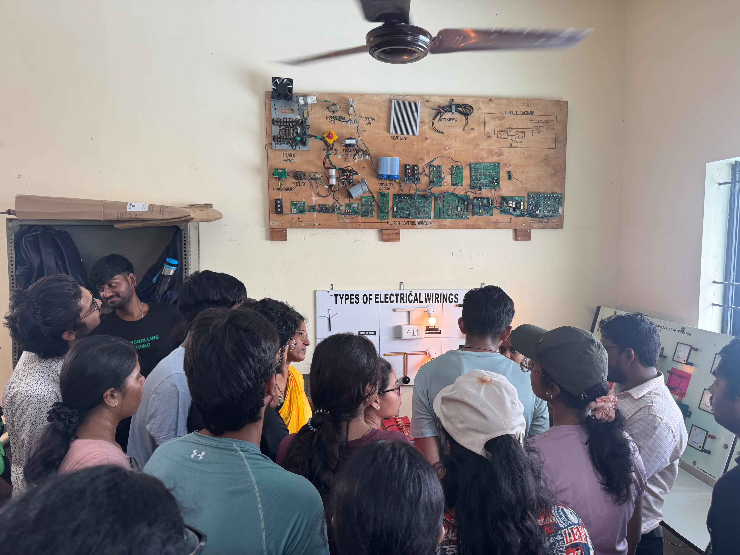

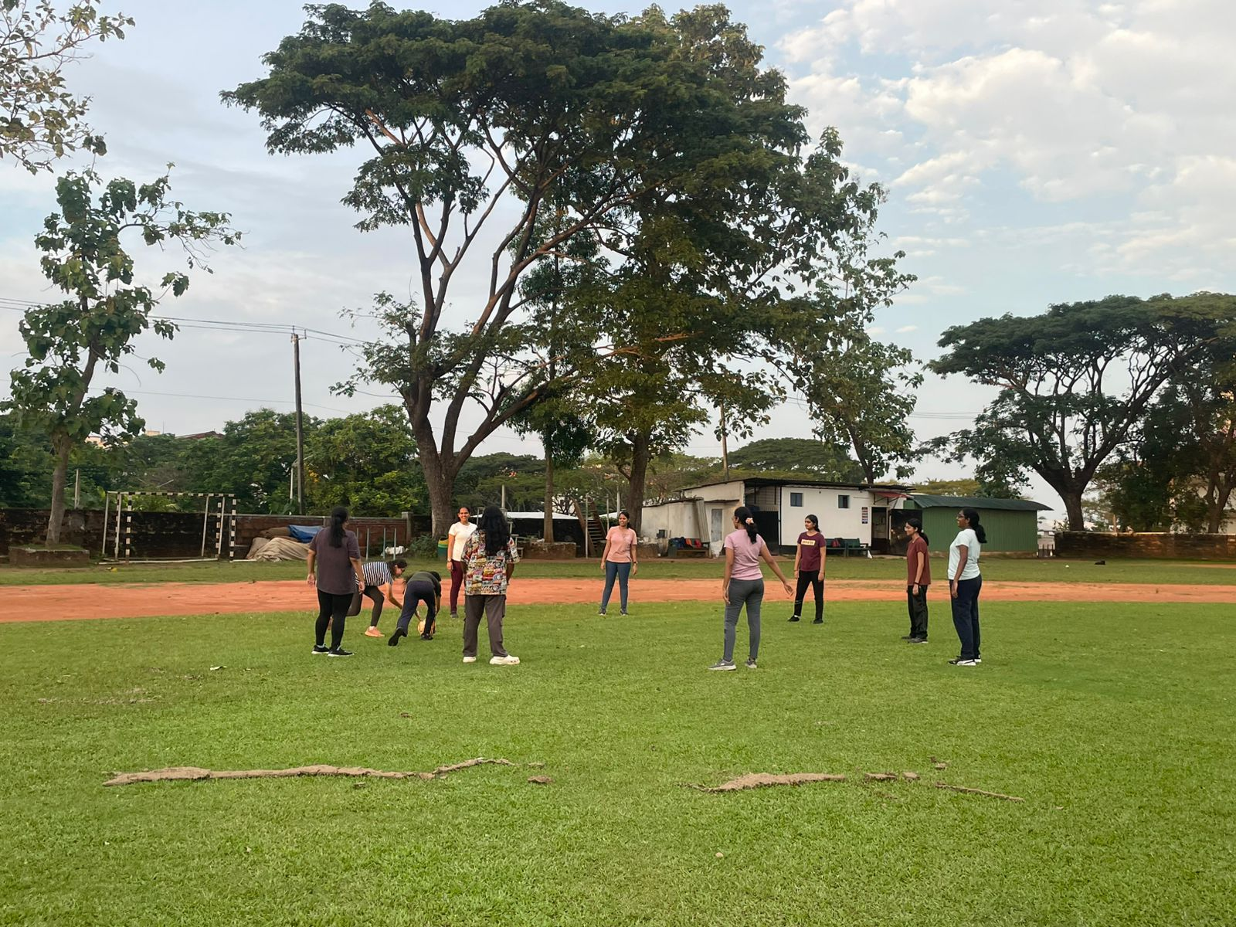

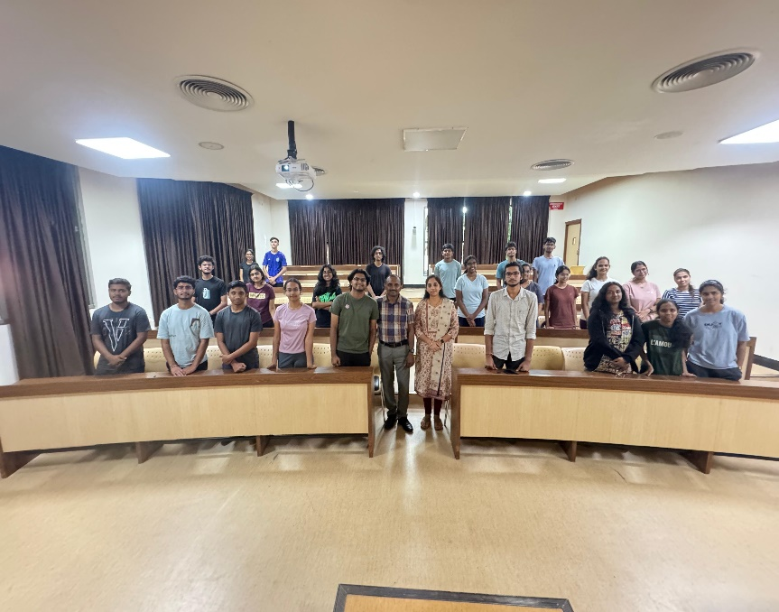

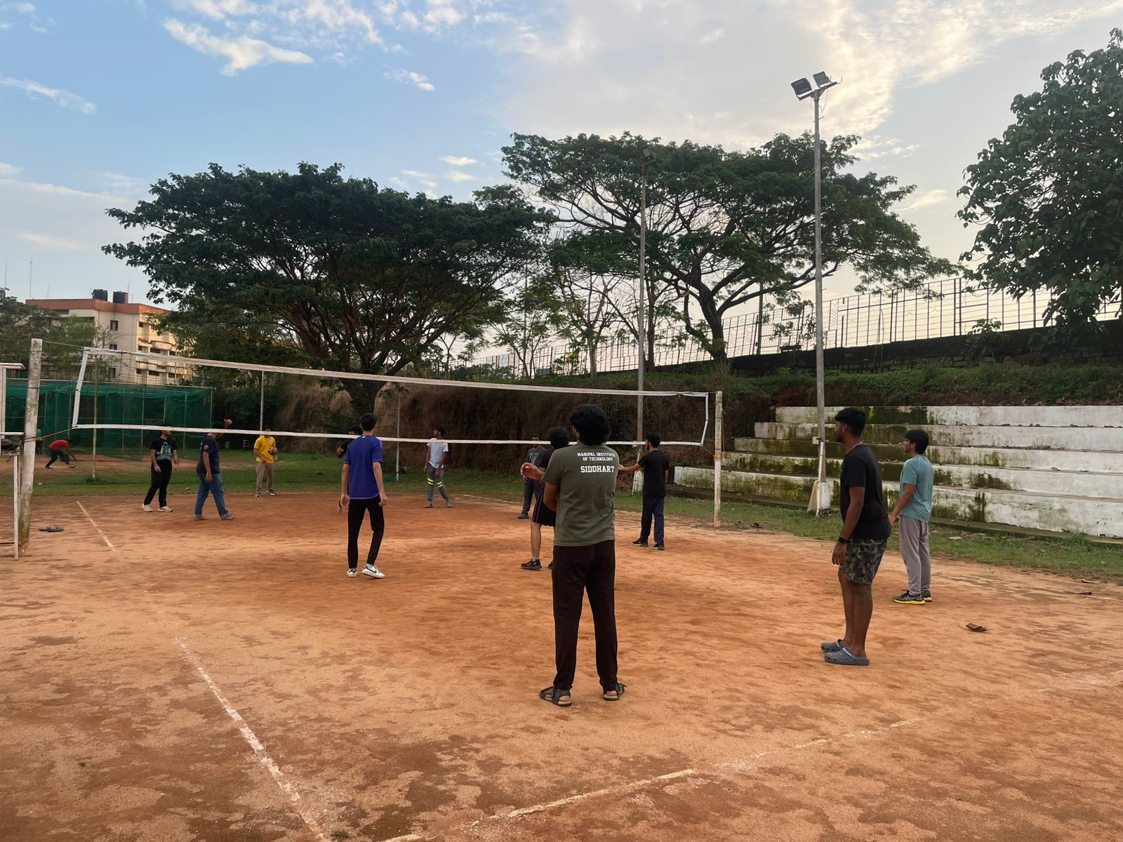

***Day 4: December 7, 2024 - Cultural Exploration and Team Building***

The day began with a yoga session, energizing participants for the activities ahead. A visit to ITI College included planting coconut saplings, a campus cleaning drive, and a tour of the automobile workshop to learn about automotive technology.

In the afternoon, Dr. Ramya S. delivered a lecture on meditation, linking mindfulness principles to engineering concepts. A visit to the Hasta Shilpa Heritage Village Museum followed, offering insights into India’s cultural and architectural heritage. After high tea, a feedback session allowed participants to reflect on their experiences. The day ended with a fun skit-based game, "Improf," fostering creativity and teamwork, followed by dinner.

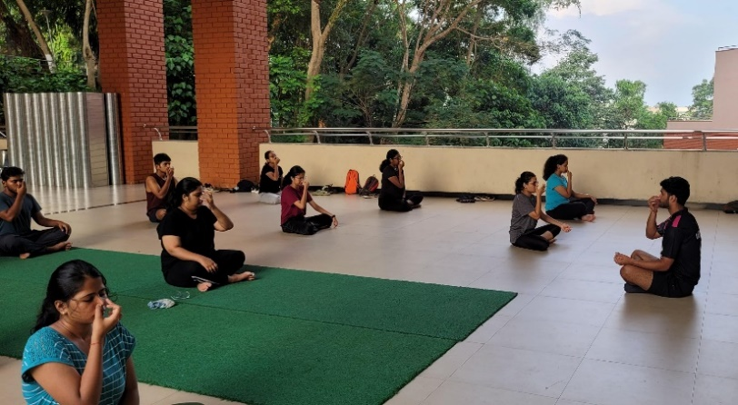 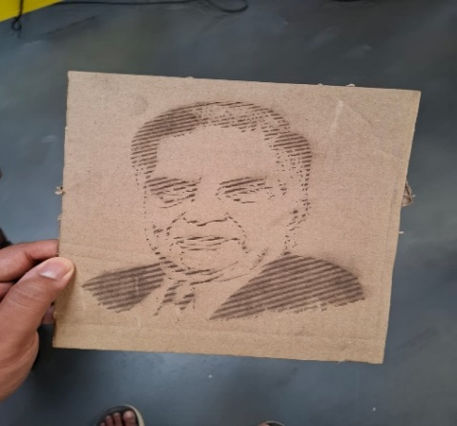

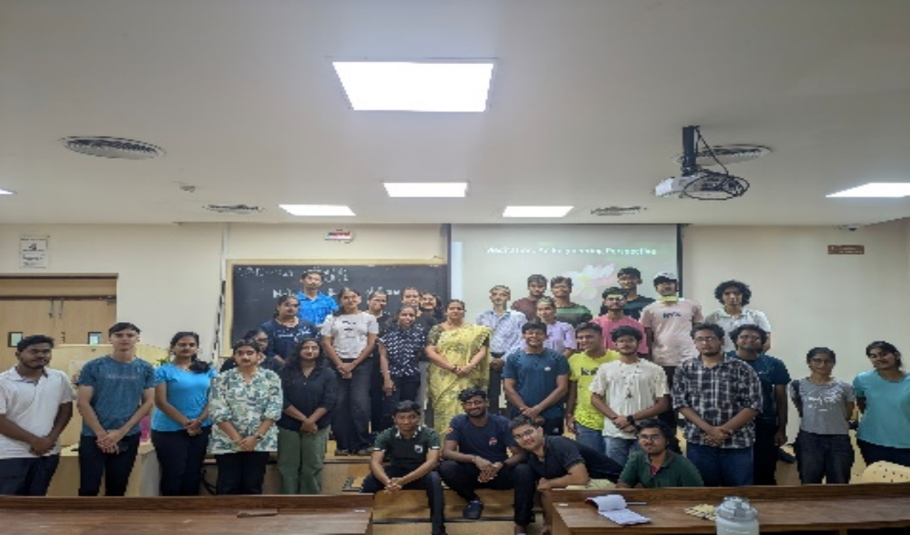

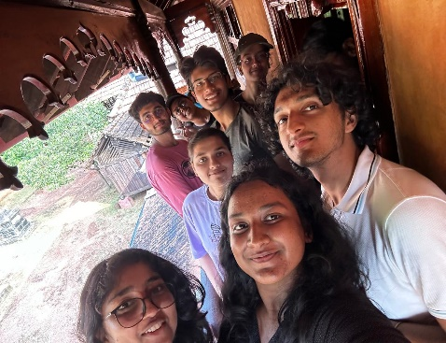 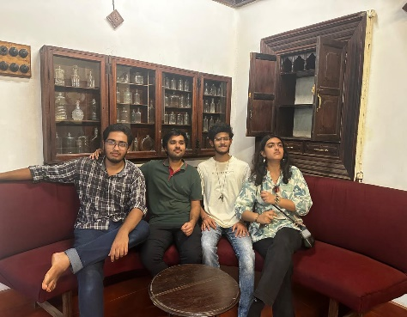 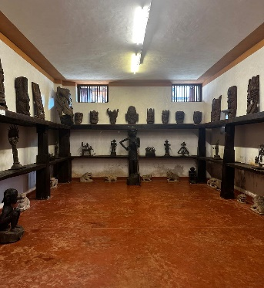

***Day 5: December 8, 2024 - Environmental and Cultural Exploration***

The morning began with a yoga session, followed by breakfast. At Delta Point, participants conducted a beach clean-up, collecting plastic waste to promote environmental sustainability. After lunch on campus, they visited Manipal Soan Farms, where they explored exotic plants and learned about sustainable farming practices.

The cultural exploration continued with visits to Karkala Shri Gommateshwara Statue and St. Lawrence Minor Basilica Church. The serene temple and historical church visit provided spiritual and historical insights. The day concluded with dinner at Apoorva Mess, marking the end of a productive and meaningful day.

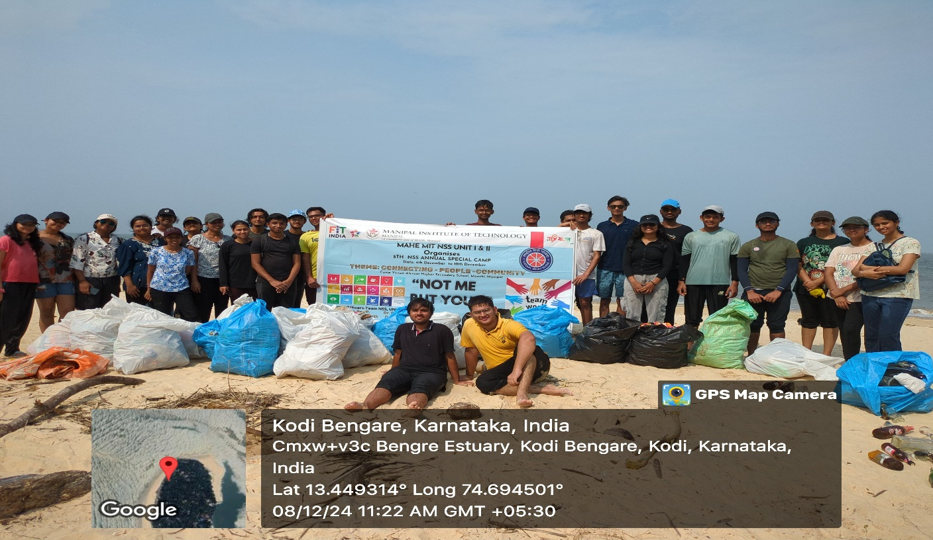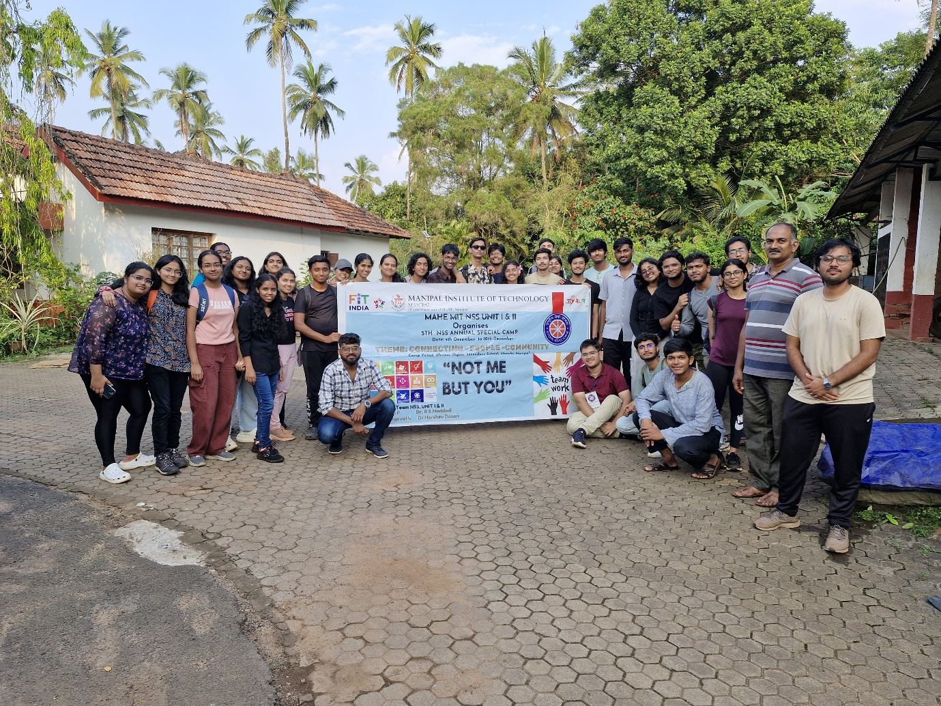

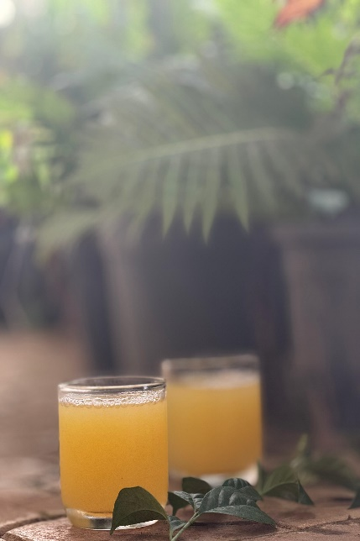 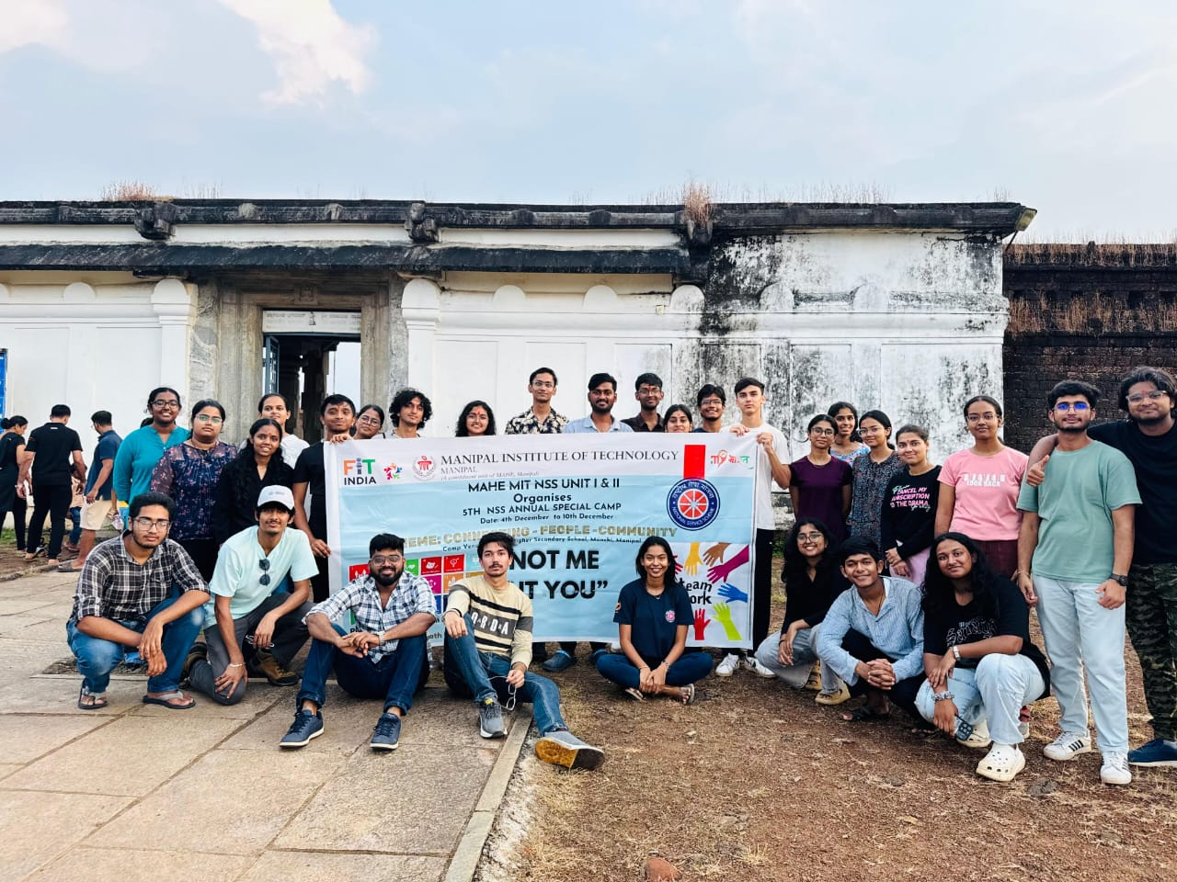

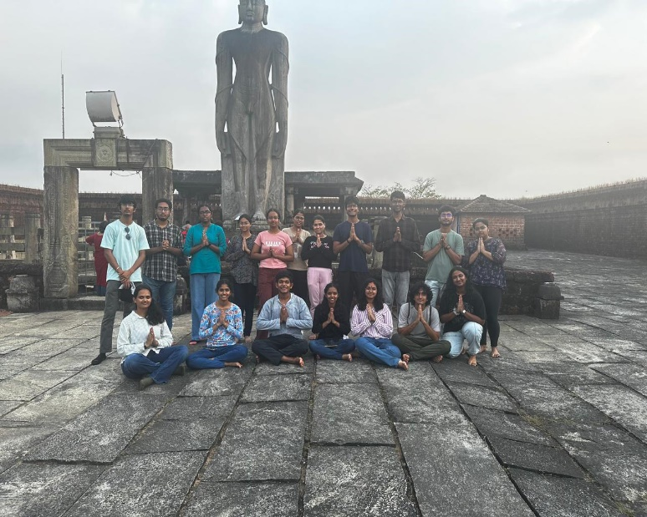 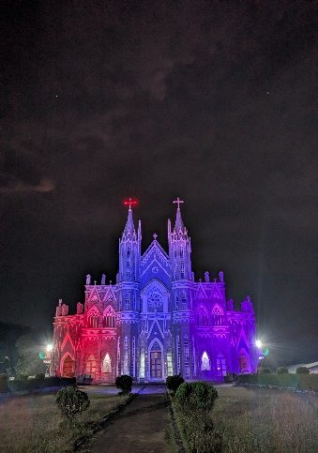 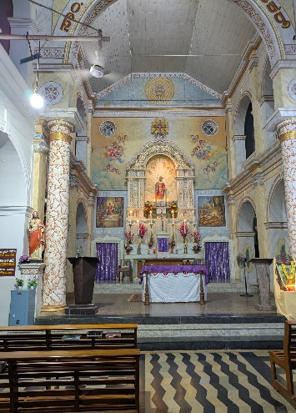

***Day 6: December 9, 2024 - Environmental Conservation and Educational Tours***

The final day combined wellness, environmental conservation, and cultural enrichment. After yoga and breakfast, participants visited a local nursery known for its eco-friendly gardening practices using repurposed plastic containers. A boat trip to Saint Mary’s Island followed, where the team conducted a beach clean-up drive amid the island's scenic beauty.

The educational tour continued at the Anatomy Museum, deepening participants' understanding of the human body. In the evening, a cultural event led by a Humanities Department faculty member emphasized respecting cultural roots and shared India’s historical significance. The camp concluded with a reflective feedback session and a shared dinner, leaving everyone inspired, connected, and enriched by the week’s transformative experiences.

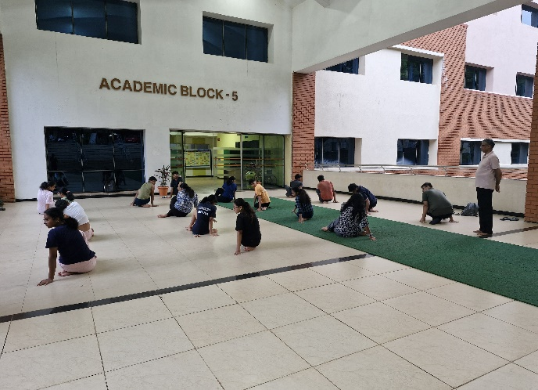 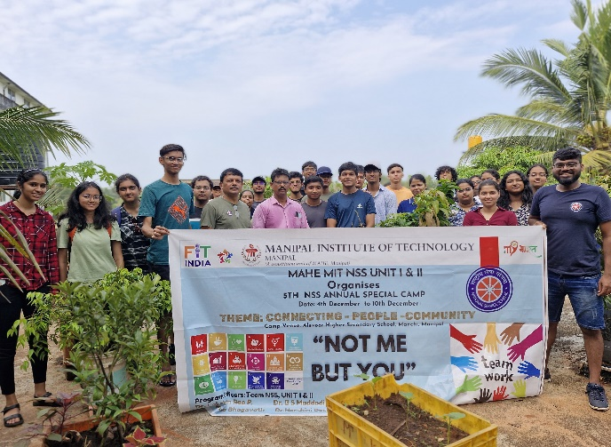

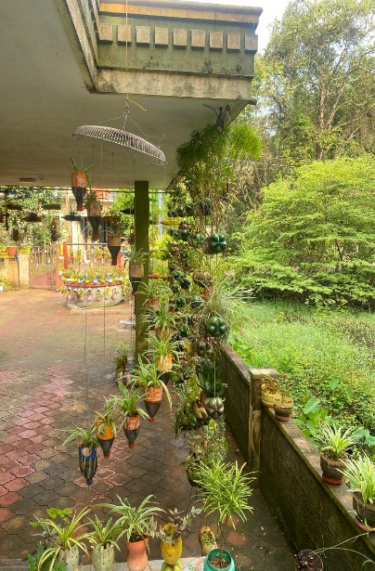 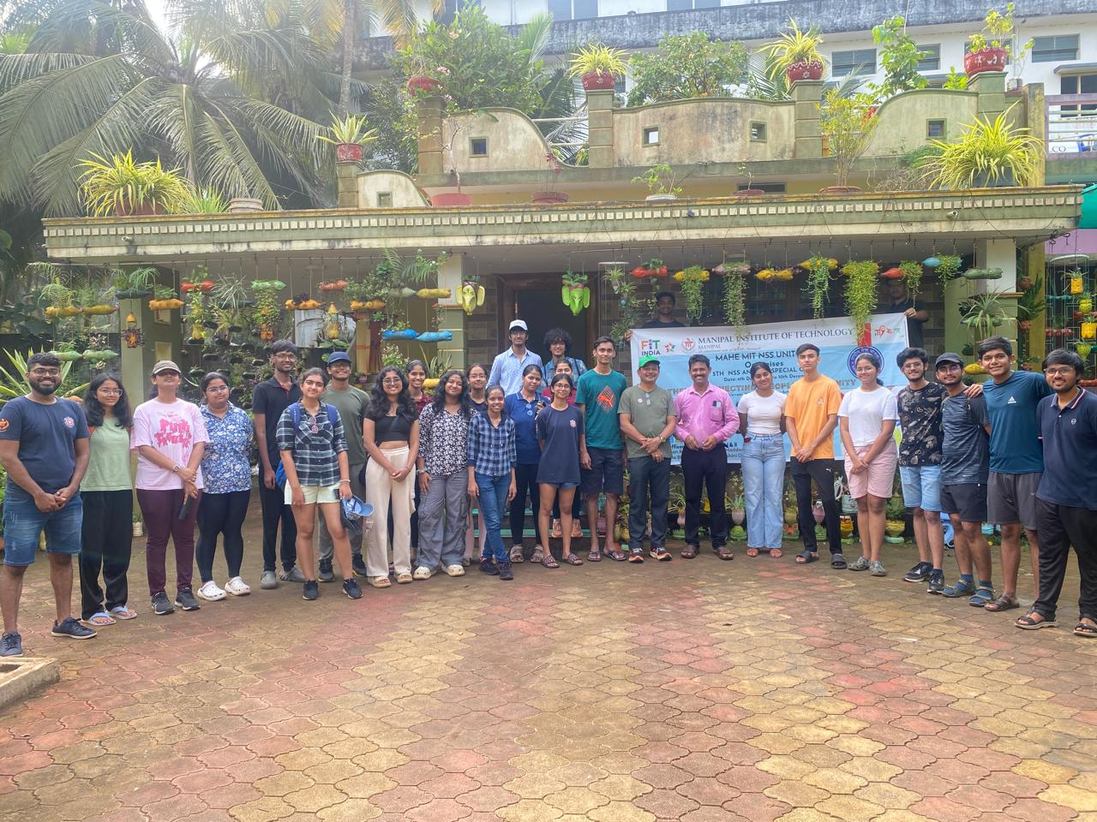

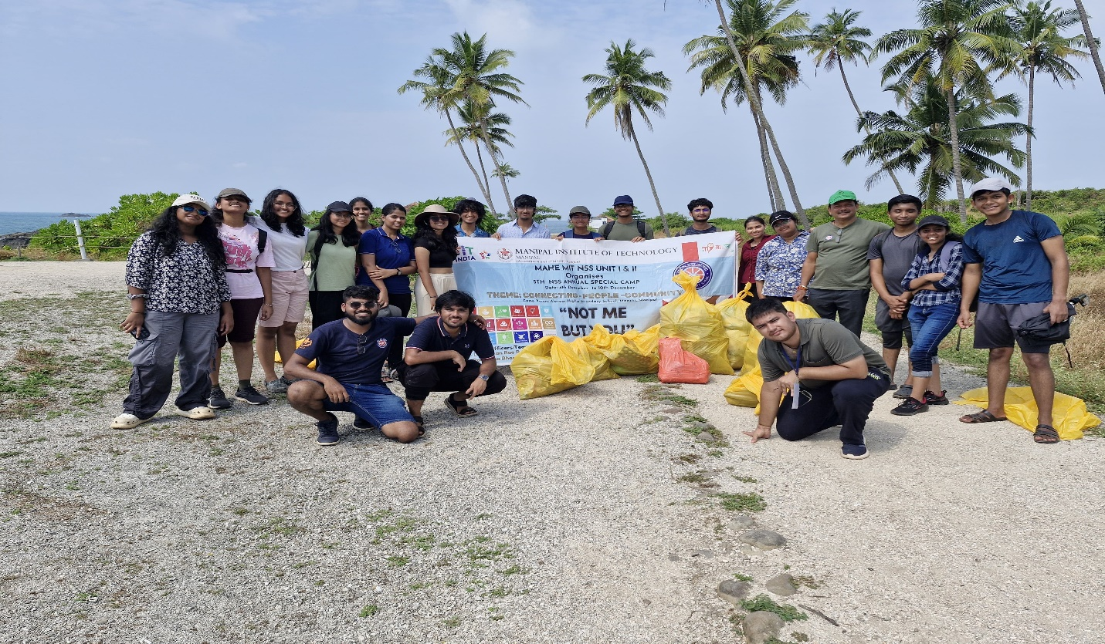

***Day 7: December 10, 2024 – Closing Ceremony***

The final day of the camp began with a refreshing morning walk from 6:30 AM to 8:00 AM to the Endpoint, where we enjoyed the serene surroundings, cool breeze, and the beauty of nature while reflecting on our camp experiences. After returning, we gathered for a hearty breakfast at 7:45 AM, which helped energize us for the rest of the day's events.

The closing ceremony took place from 10:30 AM to 12:00 PM at the M.V. Seminar Hall. It was a heartfelt event filled with speeches, memorable reflections, and tokens of appreciation exchanged among participants and organizers. The atmosphere was one of joy and nostalgia as we celebrated the journey we had shared.

Following the ceremony, we enjoyed a delicious lunch at 12:00 PM, marking the last meal together as a group. With full hearts and unforgettable memories, the camp officially came to an end, leaving us with experiences and friendships to cherish for a lifetime.

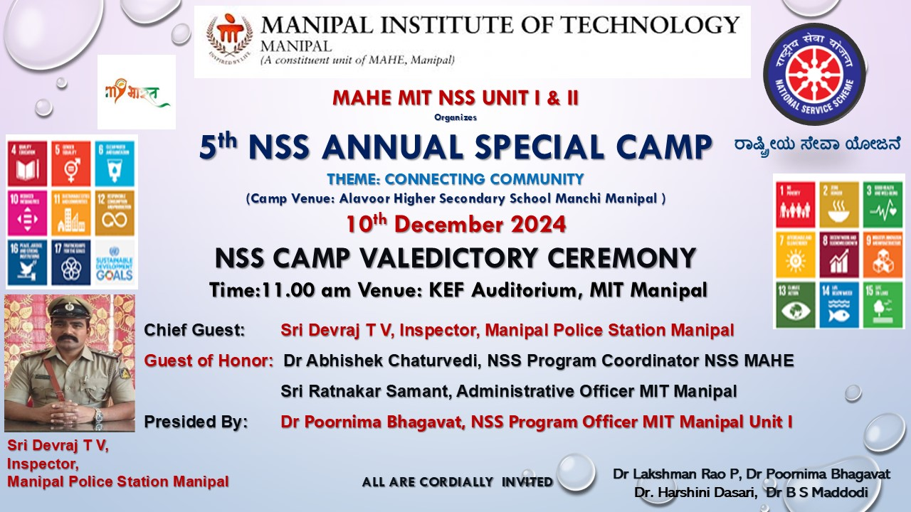

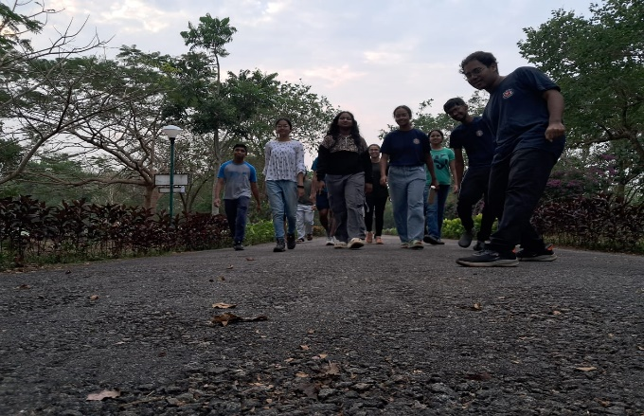 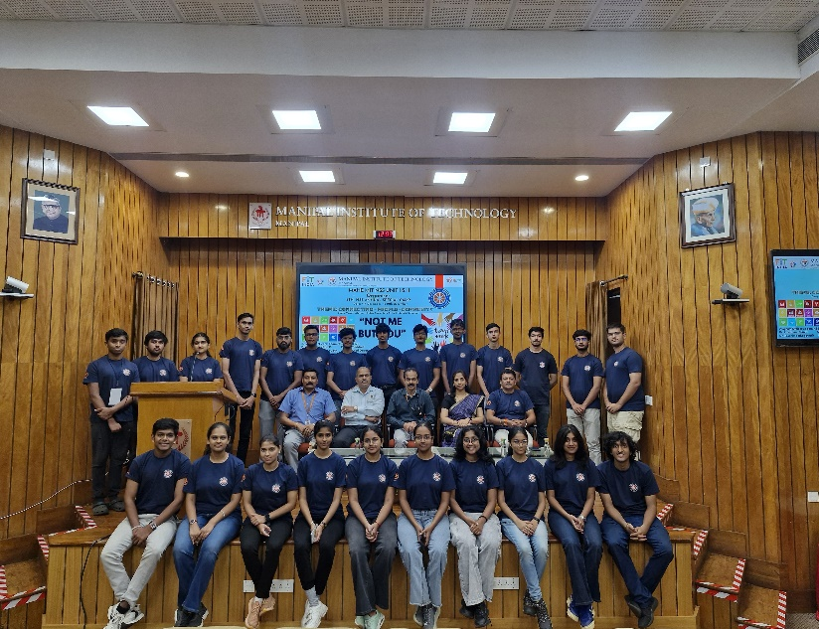

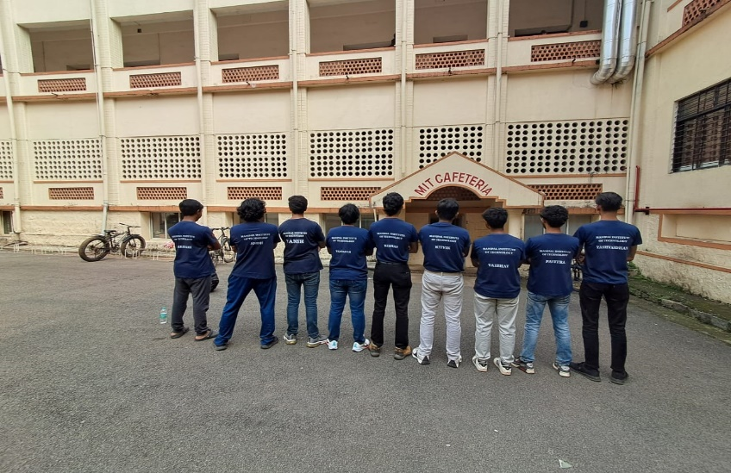 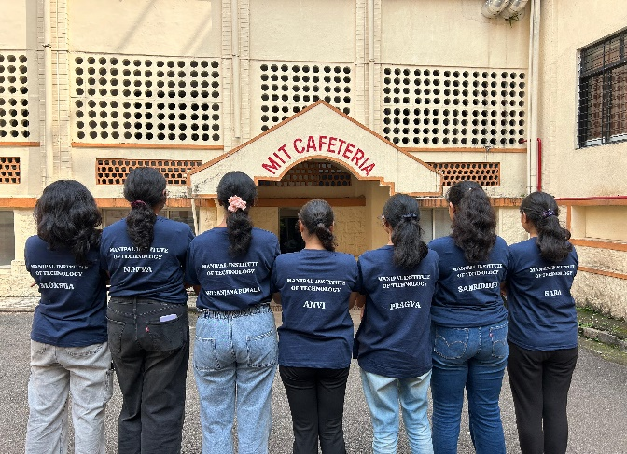

***Conclusion:***  
The NSS camp of December 2024 provided a platform for learning, social service, and self-development. Participants gained practical skills, cultural awareness, and leadership insights while contributing to society through meaningful projects. The camp not only fostered teamwork but also nurtured a spirit of social responsibility, making it an unforgettable and impactful experience. Each participant was left enriched by the knowledge gained, the bonds formed, and the valuable contributions made toward the community and environment.